Microbial Attack on Iron and Steel
or
What’s Eating You?

By Elliott Berry
Dip.Mar.Sur., RMS., RMC., M.I.I.M.S., MI.DIAG.E., AMRINA

Boat owners and marine surveyors will, of course, be familiar with common iron rust whatever form it takes and all marine surveyors should not only be able to recognise the five different types of electro-chemical corrosion mentioned above on sight and understand the conditions that cause the problem but also how to deal with these conditions in order to minimise their deleterious effects on a vessels structure. The literature on the subject of electro-chemical or galvanic corrosion is enormous. Biological attack is not so widely understood or recognised but generally takes one of two main forms: -

- macrobiology.

- microbiology.

Macrobiological attack is the well known phenomenon of mussels, barnacles, slimes, grasses and seaweeds attaching to the hull. These items do not usually cause serious harm to the metal but they can and do slow the boat down and increase the fuel consumption for a given speed. They are more or less satisfactorily dealt with by scrubbing the hull clean and coating with a suitable antifouling paint. However, there is a different kind of corrosion which is also found on boat hulls, particularly those lying in water such as canals or rivers containing decaying vegetable matter. Very few people are aware of the problem or that it is caused by micro-biological attack MIC is a highly unpredictable process but the marine surveyor should realise that, under the influence of microorganisms, corrosion processes can happen in a matter of months compared to the years it would take for ordinary abiotic corrosion to reach serious proportions. Further, also due to its unpredictability, it is often difficult to include microbiologically induced corrosion in risk analyses and, more often than not, its possibility is not even considered in a vessel’s design phase.

The impact can be enormous and an estimated 20% of all corrosion damage is caused by micro-organisms leading to costs as high as 2-5% of GDP.. Or, in other words, metal worm. There has been a very large amount of data published on this subject in the civil engineering field over the last twenty years or so and it is widely recognised that not only does microbially induced corrosion stimulate general, pitting, crevice and stress corrosion but that it is also capable of enhancing other related defects in steel such as corrosion fatigue, hydrogen embrittlement and cracking. Since micro-organisms are very wide spread in nature, most natural and man made environments are sufficiently contaminated to encourage bacterial activity to proceed to a greater or lesser extent. This type of corrosion is not a new form recently discovered but it is only in the last three of four decades that its seriousness has been fully appreciated.

These organisms are commonly found in ballast tanks where the boat has ballasted by taking on muddy river water or lying in the mud of harbours or in the waters of canals particularly those running through farm land where surface water often deposits chemical fertilizers into the canal. A colleague of the author first came across the problem some forty odd years ago when employed as a superintendent engineer for a company running a number of general cargo Liberty ships which often loaded ballast water for return trips from the West African coast. This ballast water was, from the nature of its loading from the rivers, often heavily polluted with vegetable matter and very muddy. On inspection of the ballast tanks at the classification surveys very severe pitting of a clearly defined and characteristic type was frequently found under mud deposits in the tanks and a great deal of time - and money - was spent in trying to find the cause of the problem. This was eventually identified as microbiological in origin when specimens of the corroded steel were sent for laboratory analysis. The per diem corrosion rates were often as high as 860 mg/dm² or, if it is easier to understand, pits several centimetres in diameter, 8 to 10 millimetres deep were often found in 18 millimetre thick mild steel plates in less than two years. Such microbiologically assisted reactions are well known in the big ship field to be an important factor in marine corrosion and there is, again, an extensive and increasing literature on the subject. This type of corrosion has been described for a number of different structures in the marine environment for aluminium and copper alloys and stainless steels as well as ordinary shipbuilding quality wrought iron and mild steel structures. The presence of such micro-organisms has many complex and inter-related effects and they can also generate environments favourable for the better known electro-chemical processes to occur. They can, for example, destroy anti-corrosion additives in coatings, depolarise cathodic processes and produce severe changes in local oxygen percentages that lead to differential aeration and concentration cells.

The micro-organisms that contribute to corrosion are many and varied and include aerobic bacteria, fungi, algae and diatoms, yeasts and other organisms. They are able to colonise surfaces producing biofilms up to 100 mm thick and acquire the ability by genetic mutation to adapt easily to environmental changes. The system is thus dynamic and can, and does, change with time.

The bacteria themselves are invisible to the naked eye and fall mainly into four types: -

- Slime formers which form slimy coverings over surfaces, reducing oxygen transport and trapping particles of debris.

- Sulphur oxidising bacteria (SOB) which produce hydrogen sulphide from dissolved sulphates in anaerobic conditions. The bottom of the pit that results is black. Wet hydrogen sulphide is reported to corrode mild steel at rates that can exceed 2.5 mm/cm²/year but does not corrode aluminium to any significant extent.

- Sulphur reducing bacteria (SRB) which produce tetrahydrated ferrous sulphate and the highly corrosive sulphuric acid. The bottom of the pit that results is silvery white.

- Iron oxidising bacteria (IOB) which oxidise soluble ferrous iron to insoluble ferric or ferrous hydroxide.

Although it can be assumed that microbial corrosion will ensue in any environment in which the micro-organisms can survive, the extent of the activity of any specific species may be limited and conditions favourable to one type may be quite inimical to another. The bacteria associated with the corrosion of metals are unicellular, possessing a thick, rigid cell wall, dividing by binary fission and some have a flagellum to enable them to swim and thus be mobile. These organisms can be either autotrophic or heterotrophic, aerobic or anaerobic. Autotrophs obtain their energy from light or by the oxidation of inorganic materials and their carbon by assimilation. Heterotrophs are those bacteria that obtain both their energy and their carbon requirements from organic sources and assimilate carbon dioxide to only a limited extent. Anaerobic microbes do not require oxygen for their growth whereas aerobic bacteria do. The unicellular bacteria have three basic shapes: rod like, curved or spirolid and spherical. They vary considerably in size with, typically, a maximum size of about 1 μm.

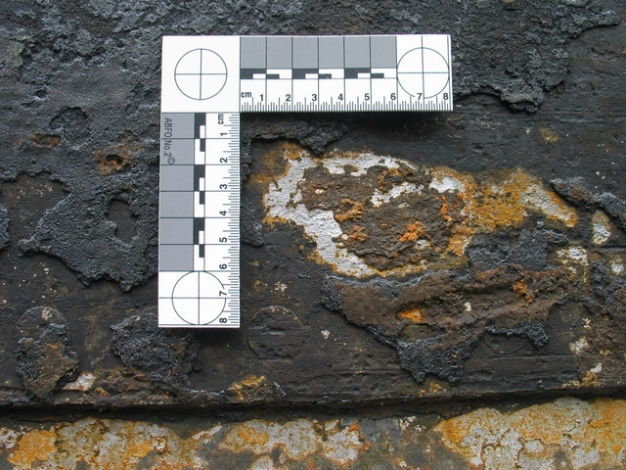

Attack on a Steel Narrowboat by Microbes of the Genus Thiobacillus

The white deposits are tetra-hydrated ferrous sulphate also known in its mineral form as rozenite [FeSO₄,4(H₂O)]. Note also the high surface area/depth ratio of the pitting. There are also signs (the small red-brown rusticles) of attack by microbes of the symbiotic species Gallionella Ferruginea. The presence of the sulphate prevents the steel underneath from rusting (oxydising). The vessel photographed was constructed of Siemens-Martin mild steel. The rivet point in the centre of the photograph and the edge of the plate seam are also showing galvanic pitting.

Sulphur Oxidising Bacteria

Of the four groups mentioned, however, the most important group associated with the corrosion of ferrous metals are those in whose metabolism sulphur and/or its compounds play an important part. The aerobic bacteria of the genus thiobacillus usually referred to as sulphur oxidising bacteria or SOB perform the oxidisation of sulphur to sulphuric acid. The acids produced can cause deep pits to appear in the ground metal though their involvement in the corrosion process is only slight compared to the sulphur reducers. The bacteria are autotrophic, acidophilic, short non-sporulating rods approximately 0.5 x 1.0 – 1.5 μm in size. They occur as single cells or in pairs and are motile. The optimum temperature for growth is 25-30ºC but they die at temperatures above 55-60ºC. Thiobacilli are colourless, rod-shaped, Gram negative bacteria with polar flagella. They possess an iron oxidase, which allows them to metabolize metal ions such as ferrous iron: -

Fe²⁺ + 1/2 O₂ + 2H⁺ --> Fe³⁺ + H₂O

They are strictly aerobic bacteria and all species are respiratory organisms and are obligate autotrophic organisms, meaning that they require inorganic molecules as an electron donor and inorganic carbon (such as carbon dioxide) as a source. They obtain nutrients by oxidizing iron and sulphur with O₂. Thiobacillus microbes do not form spores; they are gram-negative proteobacteria. Their life cycle is typical of bacteria with reproduction by cell fission. The two main strains are thiobacillus thioparus and thiobacillus ferrooxidans which includes the strain thiobacillus concretivorus. Thiobacillus ferrooxidans affects the precipitation of ferric iron solids. The bottoms of the pits formed by their action are usually covered in white tetra hydrated ferrous sulphate (FeSO₄·4H₂O).

Sulphur Reducing Bacteria

In engineering, sulphate reducing bacteria can create problems when metal structures are exposed to sulphate containing water. The interaction of water and metal creates a layer of molecular hydrogen on the metal surface and the sulphate reducing bacteria then oxidize the hydrogen while creating hydrogen sulphide which contributes to corrosion. The completion of the sulphur cycle, the Type 2 bacteria of the genera desulfotomaculum reducens and desulfurovibrio desulfuricans carry out the reduction of sulphate to hydrogen sulphide. Desulfotomaculum reducens is a sulphur reducing prokaryote and is more active than the desulfurovibrio genus of bacteria. The prokaryotes are a group of organisms whose cells lack a membrane bound nucleus or karyon. The word prokaryote comes from the Greek prefix πρό (pro) meaning before and καρυόν (karyon) meaning nut or kernel. The organisms whose cells do have a nucleus are called eukaryotes. The main genus desulfovibrio desulfuricans is a strain of Gram negative sulphate reducing bacteria and some species are capable of transduction. Desulfovibrio is a genus of Gram negative sulphate reducing bacteria commonly found in aquatic environments with high levels of organic material and sulphate. As the sulphate is reduced to sulphite, the latter interacts with the ferrous iron to generate a black medium. The insoluble new medium is ferrous sulphide and the blackening indicates that sulphate reduction is taking place and that the iron is acting as a detoxifier for the harmful sulphide thus enabling a higher growth yield for the sulphate reducing bacteria to grow. Like other sulphate reducing bacteria, desulfovibrio desulfuricans was long considered to be obligately anaerobic. This is not strictly correct as, while growth may be limited, these bacteria can survive in oxygen rich environments.

These types of bacteria are known as aerotolerant. Desulfotomaculum desulfuricans is a strain of Gram positive, sulphate reducing bacterium usually identified by the release of hydrogen sulphide gas with its characteristic rotten eggs smell. The bacteria are straight or curved rods, are highly heat resistant and a free living fixer of atmospheric nitrogen. They are motile with a flagellum and are commonly found in canal and harbour waters. These latter bugs, which can live in a lively partnership with the Type 3, are anaerobic in nature and obtain their requirement for sulphur primarily by dissimilatory sulphate reduction. It is not intended in this Chapter to go into the extremely complex biochemistry but basically the animal works by assimilating a small amount of reduced sulphur but the majority of that absorbed is released into the surrounding water as sulphide ions, these are then hydrolysed to form free hydrogen sulphide. In this manner the SRB provide a cathodic process to support and maintain the anodic dissolution of iron and steel. Once the bacterium has started to produce sulphides, the local conditions then become favourable to growth and this can result in a population explosion of the bugs all reproducing highly corrosive sulphides. Any source of water which contains soluble or decayed organic material makes an ideal environment for these bacteria and such water can have a very high expectation of contamination with SRB. The usual nutrients available are phosphates, sulphates and nitrates all of which are free flowing into the canal system which is a prime example of such water particularly if they are generally peritrichous polluted or running through farmland where non organic methods of fertilization and the use of chemical fertilizers may be expected. Marinas fed by rivers are another such example and it is well known that harbour muds are highly contaminated by sulphides produced by these creatures. Sulphide films are, by their very nature, highly corrosive and the presence on steel surfaces of hydrogen sulphide can lead to corrosion rates as high as 12.8 millimetres per annum. One form of sulphide known as Greigite is even more corrosive and rates up to 120 millimetres per annum are not uncommon.
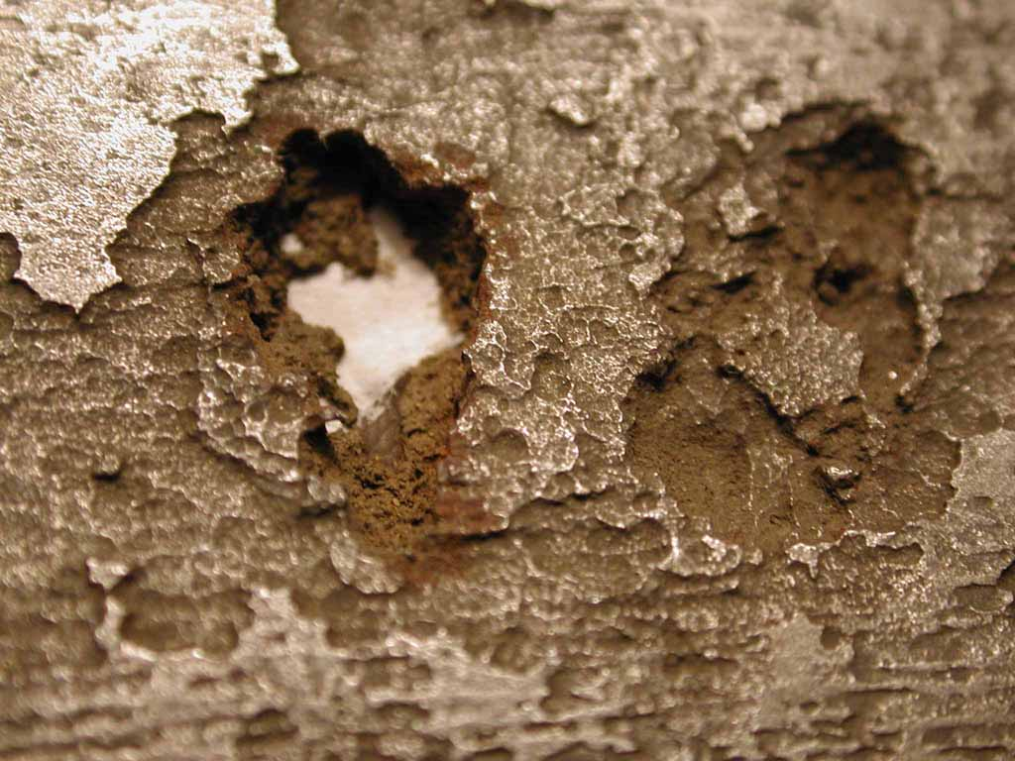

Corrosion of a heating oil tank by Sulphate Reducing Bacteria (SRB)

In the case of elemental sulphur even this rate can be multiplied by up to eight times. The water environment can be free flowing or stagnant, fresh, brackish or salt - it seems to make no difference. At sites with low oxygen levels the reactions are generally anodic and where there is reasonably high levels of oxygen the reactions are usually cathodic. Both the temperature and the pH value of the surrounding water also affect the activity of the organisms. The bugs normally prefer ambient water temperatures of between 5 and 50 degrees Celsius and a neutral pH for growth and, again, the canal system fulfils these criteria. They can, by a form of chemical and biological metamorphism, survive the coldest of English winters and, as the wreck of the R.M.S. Titanic shows, survive under enormous pressures.

The discovery by a marine surveyor of such microbiological corrosion is very difficult and requires some experience because it is not always readily visible. It is usually found under muddy and slimy surfaces, sometimes even behind paint coatings and a very careful visual inspection is necessary to locate it and the marine surveyor to know exactly what he is looking for. It is not amenable to discovery by non-destructive testing such as ultrasonic thickness measurement, eddy current testing or the magnetic method familiar to most marine surveyors. Electro-chemical methods of identification such as the SIG sulphide test can be used under controlled conditions but the techniques are usually rather difficult to apply in the field, take a long time to run and are rather unselective. They are, therefore, not very reliable. Furthermore the bacteria are often found inside oxidised welds or at areas which contain physical defects such as porosity, overlap or lack of penetration. The common practice of not blacking the underside of the bottom plate of narrowboats in the canals, for example, can only encourage this form of corrosion and, indeed, the author has often found it on such boats. If it is discovered, the only cure is to thoroughly clean the hull with high pressure fresh water, allow the hull to dry off, then to coat it with a good quality biocide, wash off again and afterward carefully recoat with a compatible paint. Within the author’s experience the best paint to apply is a good quality tar epoxy with at least four coats and a minimum total thickness of at least 250 μ. An approximate method of identifying the particular bacterium found causing hull corrosion sufficient for most marine surveying needs is given in Table 109 below.

Gallionella Ferriginea or the Iron Bacterium

The so-called iron bacterium gallionella ferruginea is an iron oxidizing chemolithotrophic bacterium (IOB) that lives in low oxygen conditions and has been found in a variety of different aquatic habitats. It has been known for about 180 years (it was first named by Ehrenberg in 1836) that these bacteria play an important part in oxidizing and fixing iron but in order to get energy out of this process, they must live in a relatively specific environment that contains reduced iron, the right amount of oxygen and sufficient amounts of carbon, phosphorus and nitrogen.

The bacterium obtains its energy from carbon dioxide fixation by oxidising ferrous ions in solution to ferric ions with the consequent precipitation of ferric and, on normal shipbuilding quality mild (low carbon) steel, manganic hydroxides in the form of clearly visible tubercules on the underwater shell of the vessel. These encourage the co-accumulation of aggressive anions such as chlorides and the steel underneath will develop deep local pitting. This type of attack is often found on the lower sides and the underside of the bottom plates of narrowboats and, for example, Dutch barges used as houseboats. They were brought to public attention when Dr Robert Ballard found them on the wreck of the r.m.s. Titanic and dubbed them ‘rusticles’ because they look like icicles made of rust. Despite the name, they are not true rust and must not be confused with it. As a direct result of the attack by the microbes which are reducing her iron at a rate of 0.30 grammes per square centimetre of area per year it is estimated that within the next one hundred and fifty years or so the remains of the r.m.s. TITANIC will have completely disappeared and turned into a mountain of ferrous and ferric hydroxide at the bottom of the ocean.

The iron bacteria are rather like living porous concrete and start with a threadlike polymer structure and then crystallise iron, calcium and a tiny bit of aluminium. The outer wall of the rusticle is heavy with iron that protects the resident colonies of bacteria. The outer skin grows harder and darker with age which fact helps the marine surveyor to spot newer growth. The young rusticle absorbs more and more iron from the parent source which is consumed into the communal structure. If they stop consuming they die but if they carry on consuming the ends of the rusticle becomes too heavy and breaks off and the microbes inside then die. The old ones fall off leaving a clean gap on which a new colony can start. Iron(II) hydroxide is poorly soluble (1.43 × 10⁻³ g/l). It precipitates from the reaction of iron(II) sulphate and hydroxide ions (from a soluble compound containing hydroxide ions). Common household bleach or sodium hyperchloride or common bleach makes a good, cheap biocide.

FeSO₄ + 2OH⁻ → Fe(OH)₂ + SO₄²⁻

In 2010, scientists also isolated halomonas titanicae, a Gram negative, heterotrophic, aerobic, non endospore forming bacterial strain and motile by peritrichous flagella, designated strain BH1T, from a ‘rusticle’ sample collected from the wreck of the r.m.s. Titanic. The pitting from microbiological sources has a high surface area/depth ratio the sides of the pits being stepped and the bottom of the pit flat. Sulphur reducing microbes leave the bottom of the pit coated with a soft black substance, easily cut with a penknife and giving off the characteristic bad eggs smell of hydrogen sulphide. Sulphur oxidising microbes leave the bottom of the pit coated with a bright silver coloured very hard substance. The ‘rusticles’ left behind by the gallionella microbes form a brown powder with a hard but brittle crust.

They are a mixture of ferrous Fe(OH)₂ and ferric Fe(OH)₃ hydroxides which are insoluble in water and are also known as ferrous or ferric hydrate or iron hydroxide. The steel underneath often has the black lustrous characteristic of ferrosoferric oxide (magnetite). If full identification is needed for, say, legal purposes, then a full laboratory test is necessary. The boat should also be fitted with an adequate number of properly electrically connected anodes whose material is suitable to the salinity of the water in which she lies.

Bacterium Identification

Bacterium | Type | Identifier
Desulfovibrio spp  Desulfotomaculum spp | Sulphur reducing bacterium  SRB | Black hydrogen sulphide at  the bottom of layered pitting
Thiobacillus  spp | Sulphur oxydising bacterium  SOB | White tetra-hydrated ferrous sulphate  at the bottom of layered pitting
Gallionella ferruginea | Iron oxidising bacterium  IOB | Yellow/brown crusted ‘rusticles’ of  ferric and ferrous hydroxides.

Anodes should not, of course, be painted but it is surprising how often that, even these days, one finds on surveys that this reasonably obvious rule is totally ignored. A good practice when painting the boat is to clean the anodes all over right back to bright metal and then to coat them with soft soap or Vaseline before applying the paint to the hull. Any paint accidentally applied to the anode surface will then wash off with the soap when the boat is floated taking the unwanted paint with it. Experience has shown that, in the absence of sulphur reducing bacteria, adequate protection of mild steel is often achieved when there are sufficient anodes such that the electric potential is depressed by -0.85V with a silver/silver chloride reference anode. Where microbial activity is high or the risk is known to be present, however, the potential must be reduced to at least -1.00 V.

