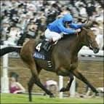

**BACs PAYMENT**

**NOW ACCEPTED**

Website[: www.premierracenight.co.uk](http://www.premierracenight.co.uk/)

[T](http://www.premierracenight.co.uk/)el: 0774 7314390 or 01775 841698

CHARITY FUNDRAISING RACE NIGHTS

PRESENTATION EVENING RACE NIGHTS

WEDDING RECEPTION PACKAGES

COMPANY & CLUB XMAS PARTIES

HOTEL, HOLIDAY PARK

AND PRIVATE FAMILY PACKAGES

ALL EVENTS ARE PERSONALLY SUPERVISED WITH EXPERIENCED SMARTLY DRESSED STAFF

**1 MILLION POUND PUBLIC LIABILITY INSURANCE** COMPUTERISED TOTE SYSTEM WITH OPERATORS AVAILABLE

***Deposits can now be paid by BACs - details upon request. Balances payable cash on night or BACs 48 hours prior to event***

**CHARITY NIGHTS** Numerous organisations & charities throughout the East Midlands & East Anglia, use our services to raise several thousand pounds for their good causes.

The evening can be tailor-made to meet individual requirements, whether it is a small event with only 50 people or a larger one with 300+. All races are on DVD that are projected onto large 6ft or larger 9ftx12ft screens.

Obtain Race Sponsors and the sell the Horses in advance, and you are onto a Winner before the actual night.

Computerised Tote system with operator(s), taking the headache out of calculating the tote pay-out. The old fashioned paper system is still available for organisations that wish to “man” their own tote.

One Spalding organisation raised over £2800 at their racenight and arranging a similar event for 2017, using our services. See reviews on [www.freeindex.co.uk/profile(tom-mehew)-69604.htm](http://www.freeindex.co.uk/profile(tom-mehew)-69604.htm)

**PRESENTATION EVENINGS**

Local Football & Snooker teams hold “Presentation Nights” that can be very costly, taking into account the cost of Trophies etc.. Why not offset the cost by making the evening a “Presentation Evening Night of Racing”.

## **WEDDING RECEPTION & PRIVATE PARTY PACKAGES**

How many Weddings have you been to that have a period in between the Meal and the Disco, with nothing happening. We have the answer: A Family Race night of about 2hrs – can be adjusted according to your timings. A fun event that will get both families cheering along. Proceeds from Tote can be donated to Charity or the pay-out can be adjusted so that all bets placed are repaid to the winners.

**50th** Birthday parties are another type of event that have used our services, with the proceeds from the tote either been donated to Charity or tote set to 100% pay-out.

## **HOTEL & HOLIDAY PARK PACKAGES**

Various packages can be tailor-made to meet individual requirements. The evening was a part of the programme of entertainment they had arranged for the guests staying at the Park on the 5-day New Year Package. The evening appealed to all age groups from 2-92yrs, with Pie & Peas, Chips etc flowing from the Kitchen, and the Bar till continuously ringing throughout the evening. Our compere cajoled the audience to cheer the horses on to the finishing post. Our Tote operators swiftly handled all the bets, and promptly paid out the winnings to the lucky punters. The percentage pay-out was set at 100%, so nothing was retained. The last race was auctioned by the Compere with the lucky owner getting a three figure amount.

**PACKAGES:-**

All packages can be tailor-made, but below is a sample:

FUNDRAISING: Package consists of 9/10 different races (Horse,Pig or Dog), Tote tickets* for each horse in each race (unless Computerised system used), Tabulator Form, Master Racecard, Tricast Form, Experienced Operator/MC, LCD projection equipment and 6f or large 9ftx12ft screen. 1000 watt PA system. Power-point presentation facilities to show the Charity/Sponsor details.

**LET US TAKE THE HEADACHE OUT OF RUNNING THE TOTE:**

Several organisers have doubts about operating the Tote, so we have the solution – Computerised Tote Betting System written specially for us. Instead of rolls or pads of numbered tickets, each bet is entered on our Laptop and an individual thermal Betting Slip is issued. The slip shows the Race Sponsor, the number and name of the runner you have backed and how much. Each slips is given a unique number with a barcode for security and to assist pay-out. After the race the lucky punters go to the Tote to collect their winnings.Our Computer operator comes along with one terminal, capable of handling bets for upto 70 people. Additional linked terminals with operators available for larger audiences, to speed up the betting process.

**ADDITIONAL IDEAS FOR THE EVENING:**

**STAND-UP BINGO**: Raise extra funds whilst you are having a laugh! Everyone stands up and they buy a bingo ticket for a £1. Bingo numbers are electronically selected and displayed on the screen – if the number announced is on your ticket – you sit down. Last person standing is the winner and receives either a prize or a percentage of the proceeds from the Bingo ticket sales, balance of money usually goes to Charity.

**DUAL FORECAST LUCKY DIP**: 28 different permutations per race for 1st& 2nd in either order. Sell the special tickets @£1 each = £28 income. Person with correct permutation on the specific race with either a % of tickets sales or a prize.

**JACKPOT 7** : Members of the audience complete a slip, predicting the winners on Races 1-7 @ £1 per slip. Person(s) who predict the most race winners correctly on these 7 races either win a % of the take or a prize.

**AUCTION RACE**: It is tradition at most Charity or Corporate Race Nights, that the last race is the Auction Race. The compere auctions all 8 horses, bids can be either individual or as a group. The person or persons who bought the horse that wins this race, wins a % of the proceeds from the Auction with balance going to Charity.

**TRICAST**: A large sheet with 336 square, each square with a different winning order of the horses for a specific race-usually Race 7. Sell each square on the Tricast sheet for £1 each = £336.00. Recommend these squares are sold in advance of the night, especially to people who may not be coming along to your event. The person who bought the square with the correct winning order, receives either a % of the Tricast sales or a prize.

**RACE SPONSORS, HORSE OWNERS & JOCKEYS:** Local businesses are often keen to help a good cause, so are willing to Sponsor a race for a set amount. In return they get their name in the Race Card and if information supplied their advert displayed on the screen. Sell all the Horse Owners and Jockeys again possibly before the night at say £2 each = 8 races of 8 horses – 64 Owners and 64 Jockeys = £128.00.

Owner and Jockey on the winning horse then either receive cash or a prize.

*The Race Night must NOT be the main incentive for people to attend. A lot of local authorities are very hot on this, so we recommend that you advertise the evening as a “Fish & Chip Supper Social Evening + Race Night” or something similar. The Supper is the main incentive for people to attend. Because the films are not selected by a member of the audience until after the tote is closed, it is then considered to be a lucky number type of evening similar to bingo and doesn’t come under gambling regulations.*

The above picture taken at South Holland Centre, Spalding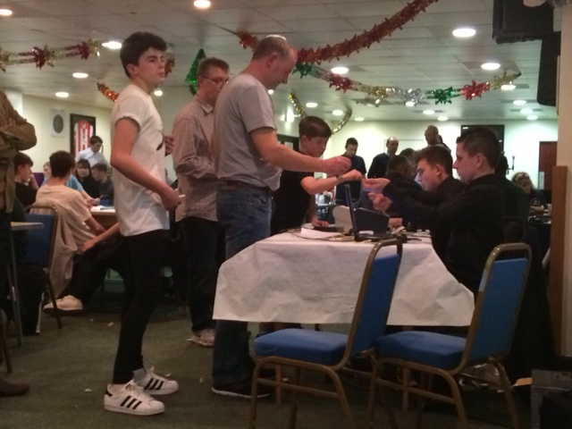 The above picture shows Ashley & Oliver taking bets using computerised tote system at a series of pre-Christmas Race Nights at

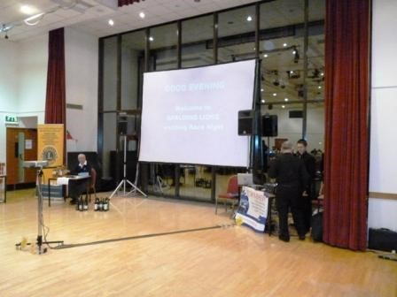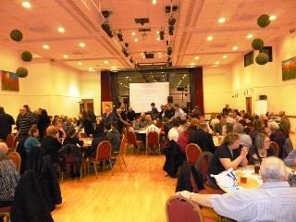

Travis Perkins Lounge, Lincoln City Football Club.

**FOR BOOKINGS & FURTHER INFORMATION CONTACT:**

**TOM MEHEW**

**2 CAMBRIDGE GARDENS, GOSBERTON PE11 4HP**

**TEL: 01775 841698 or 0774 7314390**

**Email:** [**premierracenight@btinternet.com**](mailto:premierracenight@btinternet.com)

**Website: www.premierracenight.co.uk**

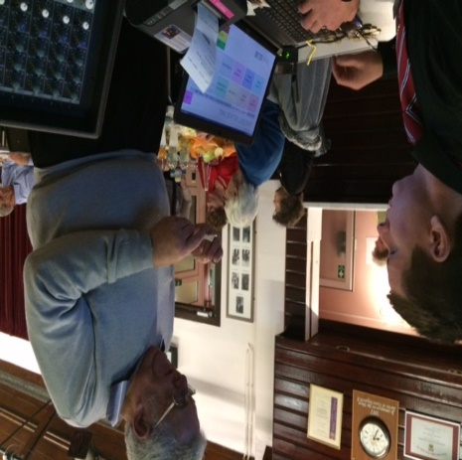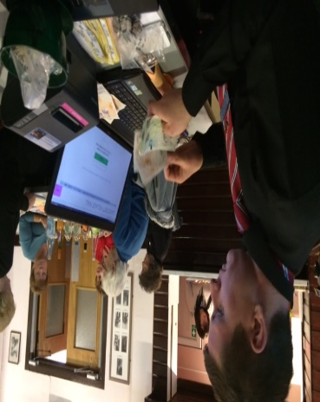***Ashley using computerised Tote system at Langtoft 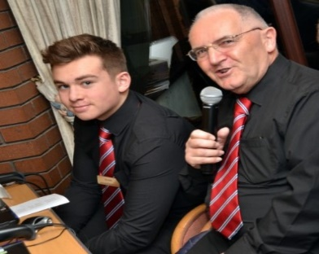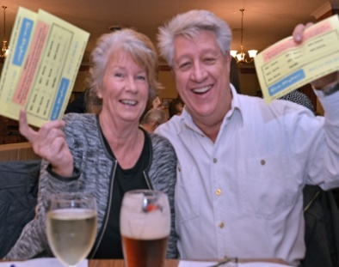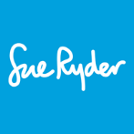£3,500 raised at Sue Ryder race night held at Surfleet Golf Club – 21/1/17 Compere Tom with Oliver Farmer manning tote. Derby Rugby Club raised £1700+ 11th March .***

***Holbeach Football Academy raised over £3000 and Spalding Grammar School raised £2000 during last year. Callum Pite Smile Charity raised £1529..32 at Sutton Bridge Con Club 25/3/17***

  NOW ACCEPTED