CHARITY RACE NIGHTS:

Numerous organisations & charities throughout the East Midlands and East Anglia, use our services to raise several thousand pounds for their good causes.

The evening can be tailor-made to meet your requirements, whether it is a small event with only 50 people or a large one with 300. All races are on DVD (horse, dog or pig) and projected onto either the 6ft screen with front projection or big venues the larger 9ftx12ft screen that can be either front or rear projection.

Tip on organising a race night is to delegate some of the Committee to help with the organizing, sooner than doing it all yourself…

1. Obtain sponsors by inviting local businesses to sponsor a race for say £20 or £30 in return they get their business promoted on the night
2. Sell all the horses and jockeys beforehand for £2 or £3 each, and the Owner/Jockey either gets a cash prize or a donated prize from the sponsor.
3. Sell squares on the 336 square Tri-cast sheet for £1, where they predict the winning formation on a specific race (possibly Race 7 that gives you time to sell any vacant squares on the night}. The person who picks the correct formation gets £100 leaving £236.00 for your cause.
4. If you have a business that possibly wants to donate more to your cause than you are asking for each race sponsor, let them either sponsor the event or sponsor the cost of producing the race card. Some times large businesses will pay our fee, providing we invoice them for their books… no problem – say yes..

In addition the race sponsors can have their logo displayed on the big screen and possibly included in the programme if you have facility to do that.

1. Advertising the event is an issue in some areas so we would recommend that you don’t put the Race Night as the main incentive for people to attend. Advertise it as a Fish & Chip Social Evening + Race Night or something along these lines, this overcomes local authority rulings especially if you are applying for a licensed bar.
2. Don’t overcharge for admission to the event, because this could deter people from attending. Whether you have it as a family event or adult only, that is up to you. Previous experience a lot of people prefer it as a family night, because they then don’t have to find a baby sitter. Also children enjoy the night too especially the pig races…
3. Tote betting is handled by our experienced staff using computerised tote system, with minimum bet set by you at 50p or a £1. Percentage payout again is decided by you before the night, so we can programme the system.
4. JACKPOT 7- is another attraction to bring in funds, We distribute the slips around the room. Punters predict the winners of the first 7 races, put their names on the slip and hand into the tote with their £1. The person or persons who predict the most correct get a share of the take from the Jackpot 7. 50% of the take from the Jackpot 7 is retained by the charity and the balance is paid to the winner(s).
5. WALLY BINGO is a fun game of bingo where the audience buys at least one bingo ticket (£1 each). They don’t need any pens or pencils and the winner gets 50% of the proceeds from ticket sales, the other half goes to the cause..
6. AUCTION RACE-Last race of the night, we auction all the horses and the person who buys the winning horse gets 50% of the proceeds of the auction, other half is retained by the charity.

PRESENTATION EVENINGS:

Local football and snooker teams hold presentation evenings that can be very costly, buying trophies etc…

Several clubs already use our services to hold a race night as a part of the evening, thus off-setting some of their expenditure with proceeds from the race night.

OTHER HELPFUL INFO:

We supply sample race cards when you book, that you can either use for your runners or you can create your own using excel spreadsheet. It doesn’t matter what names you have, because all races refer to runners 1-8. Recommend you either print or photocopy sufficient race cards for one between 2 or 3 people.

On the night we will require a float of 50p’s and £1’s for the tote, because most people arrive with notes at the beginning of the night…

Most events have 9 or 10 races, but more is possible using our computerised system.

Any organisations wishing the use the old fashioned paper system and manage it themselves this is possible, but would be about £40 extra to cover cost of getting the tote tickets printed. Whereas with our computerised system race sponsors names are displayed on every betting slip, and all tickets are scanned to avoid anyone claiming pay-out incorrectly.

One Computer operator can handle bets from up to 70 people, for larger events additional terminals available. Tote terminals can be either together or to comply with Covid19 distancing, they can be located at different areas of the room to avoid people crowding in one area.. Government guidelines are followed. .

Booking procedure:

Demand always exceeds availability, so please double check that we are able to do the date you are wanting before confirming your booking with the venue…

All enquiries will be held for 10 days to give you time to get your venue sorted.

Once date is finalised provisional confirmation will be sent to organiser by post or email, along with specimen race cards, tri-cast sheets and Booking Form.

Booking Forms to be completed and returned within 10days to confirm the booking, and £50 deposit payable at this time either by cheque, BACs..

Once Booking Form and deposit is received a signed copy of the Contract will be returned to the organiser, along with receipted invoice. Balance of fee is payable on the night by Cash or Card. If paying balance by Cheque or BACs payment is due 3 days prior to event.

***The race night must NOT be the main incentive for people to attend. A lot of local authorities are very hot on this, so we advise that you use some other title as the main incentive for people to attend ie Hog Roast + Race night, Fish & Chip Supper is very popular, because it doesn’t involve much work for the committee in preparing etc.***

*A big plus using our services is that you have very little to do on the night, because we do most of the work for you. Providing you have sold all your horses etc in advance, you can welcome your guests and then enjoy the evening and just mingle with the audience….*

***Because the DVD’s are all in sealed envelopes and the one for the next race is not selected until tote is closed, it is considered to be lucky number type of evening similar to village bingo and doesn’t come under gambling regulations.***

*For reviews: www.freeindex.co.uk/profile(tom-mehew)-69604.htm*

TOM MEHEW

2 Cambridge Gardens, Gosberton PE11 4HP

Tel: 01775 841698 or 07747314390

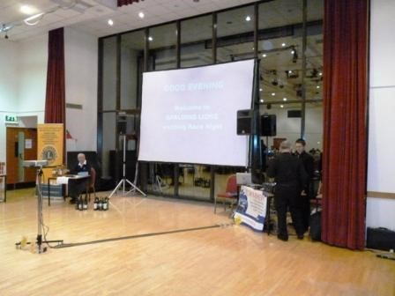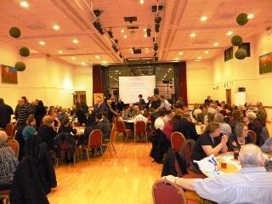

Email: [premierracenight@btinternet.com](mailto:premierracenight@btinternet.com)

Website: premierracenight.co.uk

*Million pound public liability insurance*