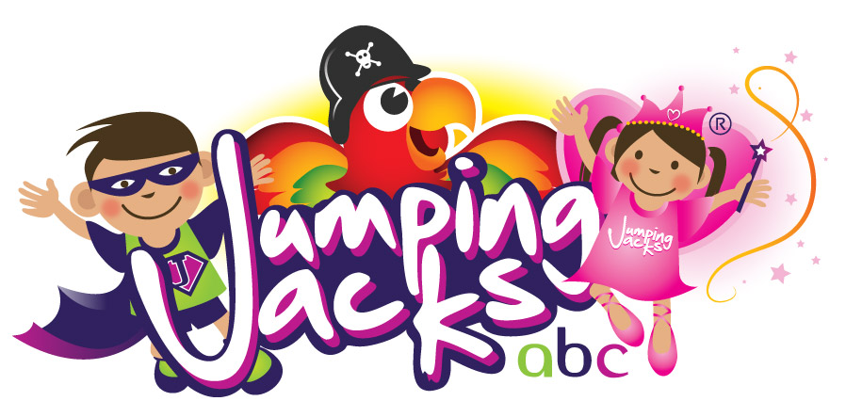
ABOUT TEAM JJ (AS SEEN ON TV!) – PRICES ON NEXT PAGE
JUMPING JACKS have won awards for our business including a National Princes Trust Award & we pride ourselves on mainly getting booked via word of mouth. All JJ party leader’s are CRB/DBS checked & insured. All equipment is PAT tested and we have a valid PPL License. All leaders are fully trained working with all ages!
TEAM JJ PARTY & DISCO PACKAGES
We combine the timeless fun of a traditional party with some of the funniest & most original party games you’ll ever see! JJ put our own unique spin on a party. Games, action songs, party dances ‘JJ style’ (ain’t no other style!), activities, party props & resources are tailored to suit the age and ability of the group. For older children we include fast paced team games & competitions. For little ones we use musical instruments & other sensory resources. TEAM JJ’s go that extra mile to make your event one to remember & we bring the party to you! No one is left out & all kids attending our parties will receive a little something so no one leaves the party disappointed. Themed packages available... to fnd out more visit http://jjhq.co.uk/themed-parties/.
JJ party leaders are entertainers with professional DJ equipment/lights & you get a lot more for your money than the usual ‘DJ’ package. All JJ Party Leaders love what we do & it shows. We are ‘big kids’ too & if the grown-ups want to join the fun they are more than welcome or simply sit back & enjoy the party. If you’re looking for action packed entertainment with nothing but fun from start to finish book JJ! Our Disco packages are for a minimum of 2 hours.
MASCOTS/CHARACTERS - SEE SEPARATE PRICE LIST FOR PRICE AND PACKAGE DETAILS
Standard Mascot Costumes (with removable heads):
- Mickey
- Minnie
- Olaf
- Scooby Doo (Special offer! Choose Scooby and Shaggy comes along for free as your JJ entertainer!)
- Buzz
- Jessie
- Woody
- Peppa Pig
- Minion Stuart (one eye)
- Minion Dave (two eyes)
- Iggle Piggle
- Jack Bear
- White Rabbit
- Pudsey Bear
- Rudolph
- Father Christmas / Santa
- Easter Chick
- Easter Bunny
Deluxe Characters (with special skills or upgraded costumes):
- Mr Tumble (can do sign language to popular songs chosen by Jumping Jacks!)
- Spiderman
- Venom
- Batman
- Robin
- Catwoman
- Red Power Ranger
- Blue Power Ranger
- Iron Man
- Bumblebee
- Supergirl
- Pirate Captain Walker D.Plank
- Tinkerbell
- Queen Elsa (singing)
- Princess Anna (singing)
- Rapunzel (singing)
- Flynn Ryder (singing)
- Classic Cinderella (singing)
- Cinderella / Ella New Movie (singing)
- Prince Charming
- Princess Sofia the First (singing)
- Ariel (singing)
- Snow White (singing)
- Belle (singing)
- Sleeping Beauty / Aurora (singing)
- Maleficent
- Alice in Wonderland
- The Queen of Hearts (FREE JJ Leader dressed as The Queen with 2 Hou r Packages if booked with Alice!)
- The Mad Hatter (FREE JJ Leader dressed as The Mad Hatter with 2 Hour Packages if booked with Alice!)
- Dorothy from The Wizard of Oz (singing)
- Elphaba from Wicked (singing)
- Glinda the Good from Wicked (singing)
- Frankie Stein (Monter High)
- Rainbow Dash (Equestria Girls)
- Flossy The Toothfairy (singing)
Visits are only available within a 6 mile radius of JJ HQ.
1 hour entertainment packages are available within a 12 mile radius of JJ HQ.
2 hour disco packages are available within a 30 mile radius of JJ HQ, travel charges apply for 12+ miles.
OPTIONAL EXTRA’S - AVAILABLE IN THE LIVERPOOL AREA OR OTHER AREAS FOR AN ADDITIONAL CHARGE
Party machines; Hot Dog, Snow Cone, Candy Floss, Popcorn, waffle lollies and nachos. £160 for 2, £230 for 3 & £300 for 4. Staffed for 2 hours with unlimited supplies except for the Hot Dog which comes with 50 hot dogs, buns, sauces and serviettes. More can be ordered for £1 each. Filled Food Boxes, £3 each, come in various colours/themes and can be personalised with a short message & image. Minimum order is 20. Glitter tattoos £35 per hour. Face painting £40 per hour. Chair covers & sashes £1.50 per chair.
TO BOOK, CHECK YOUR DATE IS AVAILABLE & COMPLETE A FORM VIA - http://jjhq.co.uk/make-a-booking/ A £50 deposit secures your slot. FIND OUT MORE www.JJHQ.co.uk

