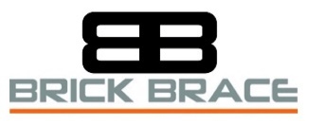

**Prop-Wise Instructions**

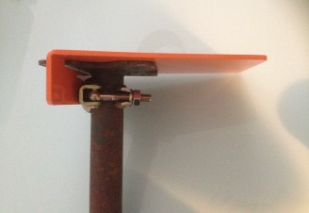

**Fitting the Prop-Wise securely onto an Acrow prop**

**Hold the Acrow prop in one hand and place the Prop-Wise on top of the Acrow prop with your other hand. Slide the Prop-Wise over the Acrow prop until the head plate fits neatly into the rear slot of the Prop-Wise. Close the coupler around the inner tube of the Acrow prop and fully tighten with a 21mm scaffold spanner.**

**Fitting the Prop-Wise blade**

**Depending on the task, either remove a sufficient amount of masonry below the fitting height or remove 200mm of the bed joint with a drill and masonry drill bit from under two bricks/blocks. Do not use club hammers as this only weakens a structure. Adjust the Acrow prop to the required height and fit the blade under and through until the tip of the blade is at the back of the masonry. Tighten the Acrow prop until the blade is cleanly engaged and fully supporting the masonry above.**

**The Prop-Wise has a maximum safe working load of 500Kg and reducing.**

**To calculate the number of props and Prop-Wise masonry supports required, the user is to know the weight of the load which requires support. Every opening without a load-point intact must be calculated on its own merit as loads will be different, see the Brick Brace masonry weight chart for awareness of the difference of masonry loads with and without a load-point. The number of props required is to be calculated from the assessment of the loading and the distance between props should not exceed 900mm unless the Brick Brace safety system is also used to support the masonry in-between props.**

**Reduce the number of props by using the Brick Brace safety tool to re-instate a load-point where possible which minimises the weight of the load. The Prop-Wise is only to be used by knowledgeable personnel of which understand the dangers of eccentrically propping and have also read our guidance; identifying risk.**

**To Keep the Prop-Wise in a good working condition clean off any mortar with a damp cloth after use and dry before storing inside. The Prop-Wise is supplied with a half coupler attached by a zinc finished 10.9 high-tensile 12mm counter sunk screw and a 12mm serrated flanged nut. Ensure to check the tightness and condition using an 8mm Allen key and a 19mm spanner before each use. Do not use the Prop-Wise without fixing the half coupler. Replacement parts must be identical in strength and available either through our website or by contacting us.**

**Where the Prop-Wise is sold, hired or borrowed, copies of the instructions are to be provided, it is the owner’s responsibility to share this information as verbal instructions are insufficient; copies are available to print from our instruction/download page via our website; www.brickbrace.com**

**PROP-WISE BENEFITS**

**Further Options for the many different tasks of masonry alterations. No web to impede the fitting area. Designed with a totally flat top to ease internal use. Designed to use the head plate to minimise curving the inner tube of an Acrow prop. Tightened securely onto an Acrow prop. Prop on the opposite of the fitting/working side for a superior safe working load. Fewer props within the work area upon larger openings. Fewer fitting holes, less masonry damage. Easy to store/fits in a tool bag. 500kg Max Safe working load. Superior factor of safety. Simple to use as guidance is provided.**

**As every task is different, each project of masonry alterations is to be planned in advance upon its own merit and carried out safely by using the most suitable variety/combination of temporary masonry support equipment of which stabilises the masonry when required and also provides sufficient fitting access without dangerously overloading or destabilising the structure above.**

**Choosing the correct sized Acrow prop when using the Prop-Wise.**

**The safe working load of an Acrow prop fitted with any tongued prop attachment will vary of which depends upon the stability of the structure, the size of Acrow prop, which pin-hole height is used, how plumb, how tightly fitted and the eccentricity (the measurement from the Acrow props axis to the centre of the wall). To reduce the risk of an Acrow prop from being overloaded when eccentrically propping masonry, the inner tube should not exit the outer tube more than 50%.**

**Recommended**

**Size 0; Working Height from solid base 1,005mm to 1,599mm**

**Size 1; Working Height from solid base 1,600mm to 1,950mm**

**Size 2; Working Height from solid base 1951mm to 2,650mm**

**Size 3; Working Height from solid base 2,651mm to 3,099mm**

**Size 4; Working Height from solid base 3,100mm to 3.600mm Maximum**

### Adjusting the collar of an Acrow prop with a full 360-degree turn increases/decreases the height by approximately 8mm; ****do not overtighten as it increases the risk of overloading due to the measurement from underside of wall to solid base not changing, only the inner tube of the Acrow prop or attachment will bend or distort.****

**Below is the official Acrow prop specification graph for loading concentrically, which clearly shows the difference of the safe working loads, 1kN is equal to 101.97kgf (force)**  
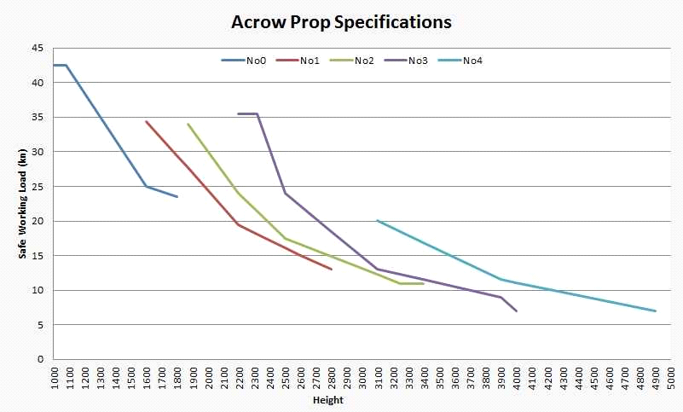

**www.brickbrace.com**