

### When knowing every task is different each project will be planned upon its own merit and carried out safely by using a variety or combination of temporary masonry support equipment most suitable, of which stabilises & supports all of the masonry and also provides the correct fitting/working and scaffolding access without dangerously ****overloading the structure above.****

**Masonry strength and stability of a structure is variable and unknown. The equipment used should suit the length of the opening, the width of the new permanent support and/or the fitting/working access required; this is important to follow to avoid misuse of equipment which is supporting the structure as frequently seen in the case of poorly fitted, overextended eccentrically loaded props.**

**The Brick Brace stabilises the structure, supports all of the masonry and provides further fitting/working access.**

**Existing propping methods decrease the stability of the structure when fitting and then depend upon this weakened & unknown lateral strength to work correctly.**

**The Brick Brace is the only temporary support equipment designed to increase stability where needed and where totally neglected in the past.**

**PLANNING A TASK CHECK LIST**

**1, What is the nature of the task? Is it remedial works or fitting a permanent support? Is it forming a new opening or increasing the size of an existing opening? Is the opening in a single skin, double skin or more or is the opening in the outer or the inner leaf of a cavity wall or in both sides?**

**2, What is the age and condition of the masonry and what is the masonry material? What design (cavity or solid)? What is the size of the cavity and/or the thickness is the wall? Which bond is the masonry built in and which mortar mix, cement or lime?**

**3, What are the existing ceiling heights? What is the size, depth and direction of the existing floor/joists, are they bearing onto the wall or are they non load bearing? Does the existing floor impede the internal fitting access? What’s the condition of the internal wall, is the internal wall plastered or dry-lined or bare masonry as in the case of the majority of total refurbishments? Are there any voids, vents or missing masonry, are there any signs of movement or cracking?**

**4, Is a permanent support fitted underneath load bearing existing joists or are the existing joists fitted within the web of the permanent support or is the permanent support fitted at the same height or below non load bearing joists? Is the permanent support deeper than the existing floor/joists?**

**5, What opening size (including bearings) is required? Is a load-point intact? What is the total weight of the load that requires temporary support? Which variety of lintel/s steel/s are specified or most suitable? What is the length, depth, width, thickness and weight of the permanent support/s?**

**6, How will any old lintels be removed and how will the new permanent support be fed into position? Which equipment or variety of temporary support equipment is designed to support all of the masonry and also provides sufficient fitting work access without overextending and dangerously overloading the equipment used?**

**The More Methods Known, The Safer & Easier the Different Tasks Become!**

**Using the Brick Brace in-conjunction with the traditional propping methods reduces labour & repair time without cutting corners or compromising safety, supports the masonry in-between props and also improves the unpredictable lateral strength of masonry & the variable S.W.L of all existing propping methods; Brick Brace with Acrow props, Brick Brace with Needles, Brick Brace with Prop-Wise or Brick Brace with tongued attachments and will depend on the task of which combination is most suitable.**

**Read our “Masonry Wall Propping Guide” via our website for further guidance of the many different task scenarios of altering masonry;**

**www.brickbrace.com**



**MASONRY WEIGHT AWARENESS CHART**

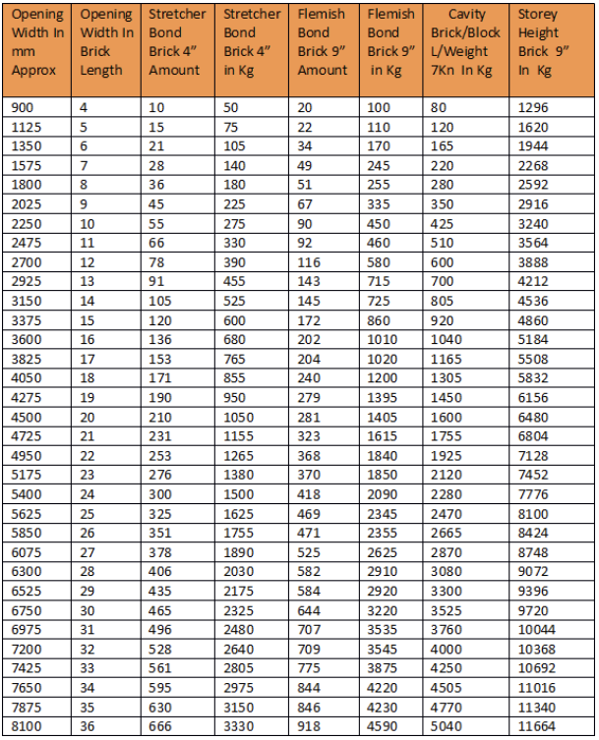

**Column 1: Width of opening in mm.**

**Column 2: Width of opening in brick lengths.**

**Column 3: Number of bricks in a full 35-Degree triangle of masonry above an opening of 102mm brickwork Stretcher bond when a load-point is intact.**

**Column 4: Total weight in Kg of brickwork above an opening in a full triangle of masonry within 102mm brickwork Stretcher bond.**

**Column 5: Number of bricks in a full 25-Degree triangle of masonry above an opening of 215mm Flemish bond when a load-point is intact.**

**Column 6: Total weight of a full triangle of masonry above an opening within 215mm Flemish bond.**

**Column 7: Total weight of a full triangle above an opening within a cavity wall, Brickwork and lightweight block work.**

**Column 8: Total weight of 215mm brickwork above an opening in a typical 2.4m Storey height in any brickwork bond, half the weight for 102mm brickwork; add 50% for 13” brickwork.**

**Only masonry loads are included, no live, static or dynamic loads are included. A factor of safety of 215mm (1 brick length) is included to allow for the different possible positions of a new opening within an existing brickwork bond.**

**5Kg per brick (F.O.S X 1.8) to allow for the different variety of bricks and the variations of mortar and moisture content.**

**www.brickbrace.com**