

**Designed to stabilise a structure and for superior fitting/working access. Use over openings of up to 3,150mm within 4” brickwork. Mark onto the wall the exact position & size of the required opening which is usually 400-500mm longer than the finished aperture being created. Ensure all three points of the triangle of brickwork above the opening are intact and the brickwork is free of any voids. Calculate and mark the number of insertion points required; safety tools are fitted within the course directly above the proposed opening at a maximum 3 bricks apart in a cement mortar mix and a maximum of 2.5 bricks apart within a lime or weak mortar mix.**

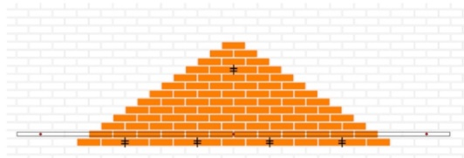

**A scaffold tube is required and fitted before any alterations take place when using more than one safety tool. For correct position of couplers measure & mark for the pilot holes; a minimum of 100mm past both sides of the opening, at 120mm above the proposed opening height.**

**Anchor-bolt fixing instructions; drill pilot holes by using an 8mm masonry drill bit at a minimum 80mm depth, an over drill of 10mm to allow for dust and debris collection. Place provided washer onto the re-usable anchor bolt and pass through the coupler and into the pilot hole, use a 13 or 15mm socket wrench (depending on the anchor bolt size provided) apply downward pressure, this helps to start the self-tapping action. If resistance is felt, unscrew the bolt one turn then continue to re-tighten.**

**Opening’s greater than 2,250mm require a further coupler fitted central. Fit the half couplers to the wall by using the supplied anchor bolts and washers. Fit a straight length of scaffold tube at a minimum of 100mm past both of the end couplers and tighten all with a 21mm scaffold spanner.**

**For best results of removing the mortar from the perp joints to fit safety tools; use a hammer drill fitted with a 10mm masonry drill bit. Fit the hook over the scaffold tube & place the Brick Brace safety tool into the joint, remove both nuts from the tool and join the hook and tool together by marrying up the hook holes to the tools rear set screws. Fit the hook and hand tighten the nuts back onto the tool to secure the hook.**

**To expand the tool; use a 19mm spanner/torque wrench to tighten the central set screw approximately 40Nm. Ensure both plates of the tool run parallel with each other. Repeat the process on each tool in sequence from left to right until all tools are fitted & tightened. To increase tool life, do not hammer tools home when joints are tight, use either a mechanical mortar raker or a serrated file to increase joint size. www.brickbrace.com**



**Cutting out to fit a permanent support; remove the masonry beds within a cement mortar mix by stitch drilling and a light set hammer drill with the correct chisel fitting to remove brickwork carefully. No club hammers as this only weakens a structure. A masonry saw or a traditional hand saw is sufficient in a lime or weak mortar mix and cut out the minimum depth of the opening to fit the permanent support at this stage.**

**Lintels; once the lintel is fitted, including cavity trays and soldier courses where required, carefully remove the rest of the opening in full. When fitting within existing face brickwork, ensure the lintel has minimum bearings of 225mm; this extra bearing will help support the lintel over the eventually toothed out brickwork below when removing the rest of the opening in full and when bonding the new reveals into the existing face brickwork. Fit/drill suitable vertical wall ties within both reveals every 225mm throughout the height of new opening.**

**Steel beams; Once steels have been correctly fitted and packed and the mortar cured, remove the rest of the opening to the full depth. The Brick Brace can be released by reversing the fitting method, make good/re- point the drilled perp joints. Clean the Brick Brace safety tools with a damp cloth and dry ready for storage or for further use.**

**Tool parts; When tightening the Brick Brace Safety tools do not exceed a torque of 50Nm as bending may occur, the plates can be reversed on the following occasions of use where distorted. The Brick Brace safety tools are supplied with Hi-tensile set screws, if lost or damaged replace with a minimum of 8.8 Hi-tensile. If in doubt please contact us to purchase.**

**Important; When the Brick Brace system is sold, hired or borrowed please provide copies of the instructions, it’s the owner’s duty to share this information including updates which are available to print/download via our website; www.brickbrace.com**

**Additional tools required for best results; 4” grinder fitted with a m14 mortar raker, 9-12” disc cutter, masonry saw, hammer drill, 8 10 & 11mm masonry drill bits, 13/15/19/21mm sockets, ratchet/torque wrench.**

**The Brick Brace Safety System is designed to stabilise the unpredictable lateral strength of a structure for the more conscientious & knowledgeable builder and provides superior fitting/working access upon the external fitting side when the internal skin can be propped separately from inside and when fitting external lintels within older properties and a further aid for many other remedial works. For further guidance please read the following articles provided; Planning a task check list, Code of Conduct & The Brick Brace masonry weight awareness chart.**

**Reading is essential to gain further knowledge; Please visit our website from time to time for up to-date guidance including new products, our frequently asked questions page and our masonry wall propping guide for further guidance on the many different scenarios of fitting permanent supports within existing masonry.**

**www.brickbrace.com**



**What Is A Load-Point?**

**A 45-degree angle upon half bonded block work, a 35-degree angle in a Stretcher bond and a 25-degree angle upon Flemish or an English bond; from both ends of the opening, carrying up through the bed and perp joints to the central perpendicular joint where both angles meet is the location of a load-point.  When an opening is made and a load point is intact, this triangle is the only masonry that could collapse, therefore this is the only masonry that requires temporary support during alterations.**

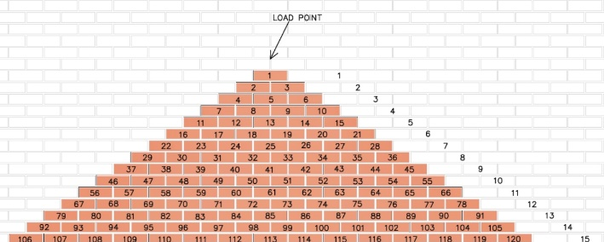

**Upon larger openings within a typical two storey residential property and any of the 3 points of the triangle do not remain, this law changes and all of the weight of the storey height above will rest back over the length of the opening (including roof loads, when they apply) due to the masonry above not safely arching. This masonry and other loads can weigh over 10 times more in most cases than just the small triangle.**

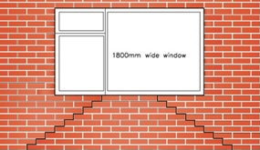

**Avoid collapse through overloading by fitting Brick Brace Safety tools through the broken triangle to reinstate a load-point and safely reduce the weight of the load.**

**–**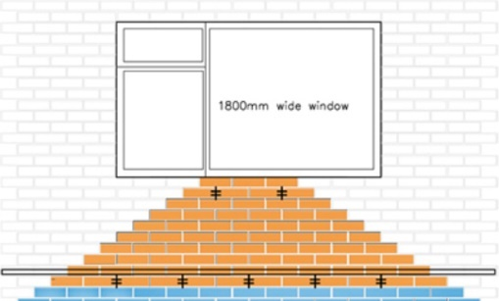

### ****When steels are specified it is usually for larger openings and/or for supporting higher loads when no load-point exists and/or for supporting all of the structure above including floor, roof, live, static & further dynamic loads which is a good indication that eccentrically loaded propping methods with an unknown variable safe working load are not most suitable to allow sufficient fitting access and/or to support the load correctly.****

### www.brickbrace.com



**Single Brick Brace Safety Tools**

**To Fit the Brick Brace; use a hammer drill with a 10mm masonry bit to remove the mortar from the required perpendicular joint. Whether left or right-handed insert the Brick Brace safety tool into the drilled out joint with the centre set screw being on your favoured side and engage fully to the angled plate. Ensure the rear nuts allow both plates to run parallel with each other when the tool is expanding within the joint. To increase tool life, do not hammer the tools when joints are tight, use either an 11mm masonry drill bit, mechanical mortar raker or a file to increase joint size. Use a 19mm spanner/torque wrench to tighten the central set screw approximately 40Nm. The masonry is now reinforced and ready for safer alterations, clearer access and superior results.**

**A single tool can be used to create openings of up to six brick lengths upon 4” brickwork within a cement mortar mix, supporting all 15 bricks within the triangle of masonry above at any height with nothing to obstruct the fitting area and a five-brick length opening is achievable within a lime mortar mix. Ensure all three points of the triangle of brickwork above the opening are intact and the brickwork is free of voids.**

**When an opening is required within both sides of a cavity or 9” wall, it is recommended to brace externally and prop internally when suitable, leaving the external face side clear for scaffolding and working access at any height.**

**Brick Brace Safety Tools are fitted within the course directly above a proposed opening at a maximum of three bricks apart in a cement mortar mix and a maximum of two and a half bricks apart within a weak or lime mortar mix. Single safety tools are also used to stabilise the unpredictable lateral strength of a structure, to re-instate a load-point which safely reduces the weight of the load and used as an aid to support the un-held brickwork in between props to reduce the risk of minor & major collapse when propping.**

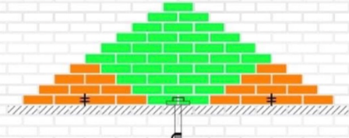

### ****Prop & Brace; We do not endorse the misuse of any temporary masonry support equipment however as it’s become strangely acceptable to overload tongued prop attachments through over extending from the wall to gain sufficient access, we highly recommend bracing all eccentrically propped brickwork to prevent the same needless recurring accidents due to the unpredictable lateral strength of the structure.****

### 

### www.brickbrace.com