

**Designed to stabilise the unknown lateral strength of a structure and to provide superior fitting/working access upon the external fitting side & used upon suitable openings of up to 5,400mm when using a 6-metre aluminium scaffold beam over the opening.**

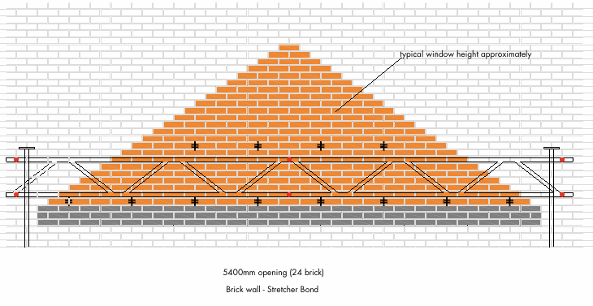

**To be read in-conjunction with the Brick Brace instruction and guidance leaflets**

**Mark out the exact position, height and length of the opening onto the wall. For the position of couplers to fit the aluminium beam measure & mark for six pilot holes; two at a minimum of 150mm past both sides of the permanent support opening and one central at a height of 120mm above the proposed opening and three further pilot holes 400mm directly above the lower three for the top tube fixing.**

**At both ends fit suitable sized Acrow props and connect top and bottom tubes of the Beam onto the inner tube of the Acrow props using band plates or single couplers. Place the provided hooks over & onto the lower tube directly to the left side of the required joints.**

**Important; Ensure not to remove any perp joints until knowing that all hooks can be fitted at the specified joints due to the occasional obstruction of the welded angled latices of the aluminium beam, reducing the distance between tools when required. Brick Brace safety tools are fitted within the course directly above the proposed opening at a maximum of 3 brick apart in a cement mortar mix and a maximum 2.5 brick apart in a weak or lime mortar mix.**

**Further Option; For suitable openings of up to 4,500mm using one Acrow prop fitted central and clipped to the horizontal scaffolding tube with a band plate single coupler.**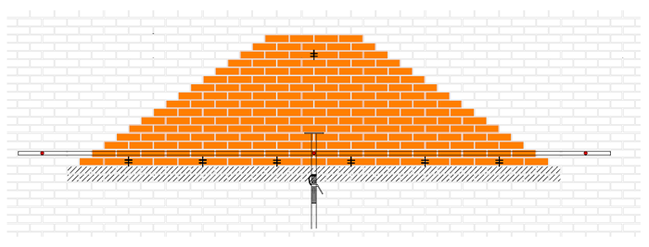

**For openings over 5,400mm in length; we recommend also using the Brick Brace safety system in conjunction with the props and needles methods especially within lime mortar masonry of which reduces risk & provides sufficient and safer fitting/working access.**

**www.brickbrace.com**