**PHOTOGRAPHY BY FOCUS WEDDINGS IAN WORRELL**

**All PACKAGES INCLUDE THE FOLLOWING:**

**FULL DAY 7AM / 10PM / MIDNIGHT**

**TWO CAMERA’S TO COVER GROOM AND BRIDE**

**VIDEO OF THE DAY 7AM / MIDNIGHT ON DVD MUSIC ETC**

**X2 CANVAS WRAPS**

**PRE SHOOT AND POST SHOOT**

**PHOTOBOOTH 8PM / 10PM**

**C/D OF ALL IMAGES NOT JUST A SELECTION BUT ALL OF THEM**

**COPYRIGHT FREE**

**GRAFFI STUDIO ALBUM FROM ITALY**

# Please note that due to high amounts of photo's taken on your wedding day I may ask for a 16 gig Stick.

**(THE BRIDES LEAVING DAY ADDRESS & UP UNTIL APPROX 10.30 /will be Please note that due to high amounts of photo's taken on your wedding day I may ask for a 16 gig Stick.**

**Photo Booth Photography is also No extra cost please ask for details on how this is run.**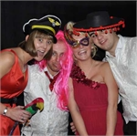

**Trash the dress is offered to all my wedding couples for No extra charge as this shoot is to create additional amazing photo's to add to**

**IVYBRIDGE POST SHOOT**

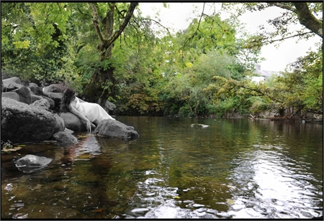

**Please not that I only work with the best album companies from around the world.**

**The Floral album from portugal, Graffiti album from Italy and the Jorgenson range from Australia.**

**If you don't see your ideal package ,please call me & I will try to meet all of your requirements for the best possible price.** Pre-shoot with free 12x16 canvas for the reception for your wedding night.

A date is made before your wedding for a free 2hr shoot

This can also be used for gift cards or for signing a canvas print at the reception by all

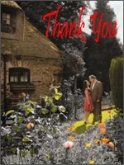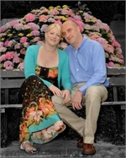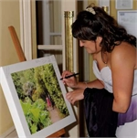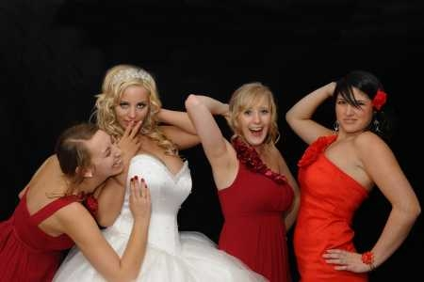

Booking

To book me and the second photographer for your wedding day all I require is a £150 non refundable deposit.

Then the final balance 8 weeks before your wedding day.

Cancellations fee

The final amount is due 9 weeks before the wedding day and if paid late is subject to a 5% fee on the full amount outstanding due at the album / C/D completion stage.

Copyright

All photos taken are the copyright of Ian Worrell / Focus Weddings and unless stated at the time of booking can be used for future ads.

Online gallery

for viewing.

All photos on my web are set at approximately 50KB for quick easy viewing.

**Albums:**

THE MADRID album £1.150 or

A 12x8" Graffiti album as shown on the albums page.

THE PARIS album £1,250

THE GRAFFITI album / Floral PACKAGE £1,300

The World Famous Graffiti/Floral 8x12" album approx 100/150 pictures.

THE COSTA RICAN album £1,495

MID-WEEK prices £895.00

Monday/Friday

PHOTOGRAPHY ON A C/D £795.00

No album just a C/D for your own use.

All images taken on the day copyright free.

An album can be added at a later date.

Design and Supply only from £495.00. You also have the final proof say before going to print like all of my wedding clients.

Only Videography package from £650.

A video put to music with x5 copies of the day edited to about 20mins / 1hr 45mins. [View Albums](http://www.focusweddings.net/Albums.aspx)



Canvas printing service

12x16"canvas prints from £45.00

Just send your picture via email and have your photograph turned into a Canvas.



Thank You Cards:

This is a great way to thank your guests.



Pendennis Castle Cornwall

Reprints 5x7= £7.00 8X6= £7.50 10X8= £8.50 10x12= £9.50.

Digital image sent via email £3.00 via paypal FULL SIZE COPYRIGHT FREE. Parents' albums start from only £95 pounds.

Please give me a call I would be happy to come to your home and go over all album & c/d packages. Ian Worrell ( 07722 317053 )