**Where2 UK Ltd**

**Corporate Chauffeur Service**

**Tel: 0115 940 4100**

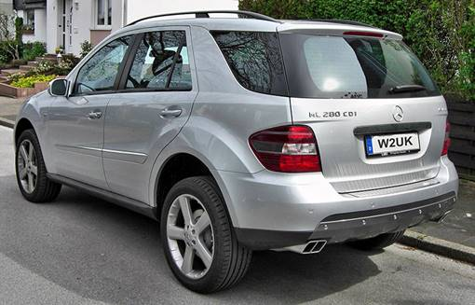

**In these unprecedented times, we just wanted you to know that we are open.**

**We understand that you may not need us right now.**

**Airport Transfers**

**City to City**

**Nationwide**

**If you require a corporate Chauffeur Company call Where 2 Uk Ltd now!**

**MUCH MORE THAN DRIVING….**

**Where2 UK Ltd**

**Corporate Chauffeur Service**

**Tel: 0115 940 4100**

**Email:**[**enquiries@where2ukltd.com**](mailto:enquiries@where2ukltd.com)