 Integrated Systems Specialists

Closed Circuit Television / Intruder Alarms / Access Control / Fire
Telephone Systems / Data / Electrical / Design / Installation / Consultancy

For the attention of XXXXXXXXXXXX,
XXXXXXXXXXX,
Hale,
Cheshire,
XXXXXXX.
07XXXXXXXXXXXXX.

9th. August 2021.
Dear Sir,
Thank-you for your enquiry today. We specialise in the supply and installation of high definition Closed Circuit Television (CCTV) systems and full 24/7 colour vision, wi-fi smart camera/ security lights.

High Definition Wi-fi Smart Camera/ light:-

The installation will include:-

1 x EzViz C3N smart camera/ security light. The camera will record video with 24/7 colour in 1080P/ 2MP resolution and 1-way audio. There are 3 night vision modes and AI powered person detection.

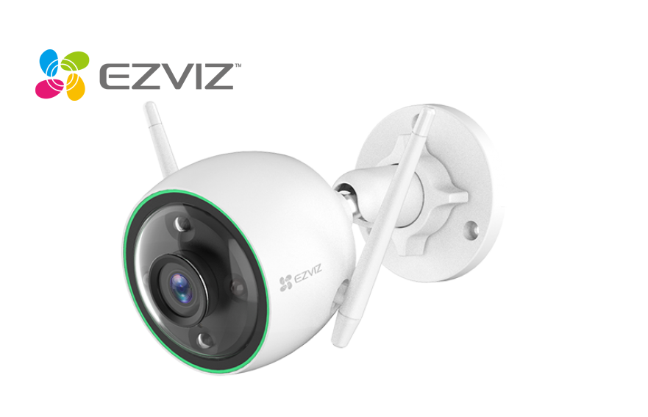
Contd…2..

The motion detected video will be recorded to a 16GB micro-SD card inside the camera and the live/ recorded video files can be viewed on the EzViz mobile phone app.

The smart camera/ light is designed to monitor and detect activity around the area specified – exact coverage including camera angles/ positions/ are to be set in agreement with the customer at time of actual installation.

- It is generally required that a person’s face fills at least 2/3 of the image viewing screen to guarantee full facial recognition with CCTV systems.

CCTV recording resolutions (PAL UK):

QCIF 176 x 144 pixels (total 25,344) Quarter CIF - mobile phones
CIF 352 x 288 pixels (total 101,376) Low end analogue DVR
2CIF 704 x 288 pixels (total 202,752) Mid range analogue DVR
VGA 640 x 480 pixels (total 307,200) Standard VGA output
4CIF 704 x 576 pixels (total 405,504) Higher end analogue DVR
D1 720 x 576 pixels (total 414,720) Higher end analogue DVR
720p HD 1280 x 960 pixels (total 921,600) 720p high definition
960p HD 1280 x 960 pixels (total 1,228,800) Sony specific HD std.
1.3 MP 1280 x 1024 pixels (total 1,310,720) 1 Megapixel - Some IP sytems
2 MP 1600 x 1200 pixels(total 1,920,000) 1.9 Megapixel - Some IP systems
1080p HD 1920 x 1080 (total 2,073,600) 1080p High Definition IP systems

3 MP 2048 x 1536 (total 3,145,728) 3 Megapixel - Some IP systems
5 MP 2592 x 1944 (total 5,038,848) 5 Megapixel - Some IP systems
6 MP 3072 x 2048 (total 6,291,456) 6 Megapixel - Some IP systems
4K 4096 x 2160 (total 8,847,360) 4K Top range/ commercial IP systems

This quotation includes all installation and necessary programming.

Contd…

Contd…3..

N.B. CCTV quality is not necessarily all about maximum resolution but many other factors contribute including build quality and software reliability. It should be noted that EzViz (Hikvision) are renowned as being one of the leading manufacturers of high quality build CCTV equipment in the world today.

A full demonstration of the new smart camera/ light will be given on completion of installation.

Total price:- £195.00 (incl).

12 months warranty applies to all parts after which an optional annual maintenance contract will be available.

A-Star Systems is a Hikvision Certified Security Associate (HCSA).

If you wish to proceed, please sign and return the “CCTV Customer Acceptance Form” (enclosed).

Should you have any further queries, please do not hesitate to contact me at the above address.
Yours faithfully,

S.R.WILLIAMSON.

(Manager).

