A Sample Menu:

By

***Lee marshall***

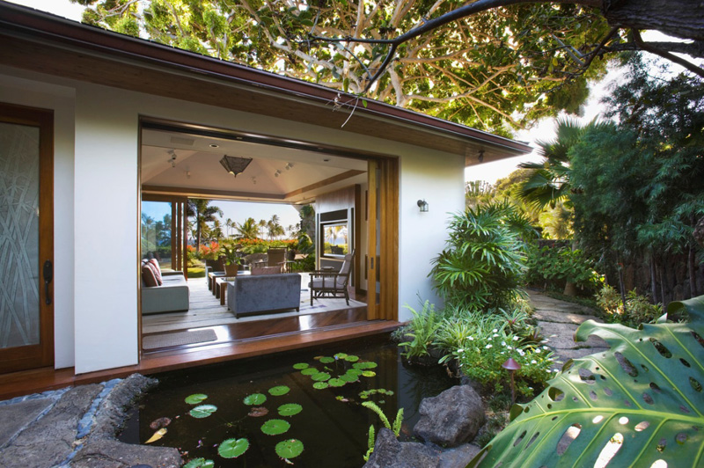

Assorted Canapés with pre-Dinner drinks,

Followed By Amouse Bouche.

*Starters.*

Pan seared Scallops with pea puree, beetroot marmalade.

Hoi sin pork, twice cooked with vermicelli broth.

Vichyssoise with Gazpacho Sorbet.

Pumpkin Risotto, goats cheese fritter, soft boiled gulls’ egg.

Trio of Nigiri Sushi, with Salmon, Tuna and Swordfish.

*Main.*

Salmon with crispy blackened skin, horseradish gallete

Yorkshire pudding and roast gravy

Veal Filet marinated with Lemon, Capers and Parsley served with a warm Beetroot and Grapefruit Salad with Lentils.

Turkey galantine stuffed with Chestnuts and Spinach rolled in Parma ham and served with fresh Asparagus and black truffle oil.

Seared Sesame Tuna with wasabi, Bak choi, crispy scallop won ton

Saffron Linguini, Sautéed girolles , seps and garlic.

Three ways Duck, with confit duck leg, roasted breast and

Foi ‘d’oie ravioli

*Deserts.*

Pear tatin with liquorice ice cream, fig tempura.

Dark Chocolate and Coffee Torte with kahula milk shake

Melktart, Coco Tuile, Strawberry cloud.

Toffee crème Brule with butter scotch and banana mille feuille

Followed by Petti Fours and Cheese.

* This is a selection of dishes to give an idea of a style of food I can cook, which could be served and presented in any way, (i.e. Buffet, silver service, or plated. 1 course to 7+ courses). It is by no means a limit of the style of food I can cook, as shown by my CV.