Welcome to Charlie’s Executive Catering & Equipment Hire

So you’ve chosen the date of your event and now you need to source the Catering or a Caterer then the Equipment hire or the Cake. Well look no further as we can do all of this and more to save you time and effort to get on with planning the rest of your day.

Here you will see some samples of what we can do for you, though looking on our website will give you a much bigger picture www.charliescateringhire.co.uk

Event & Wedding Catering Services
Wedding Menus, Wedding cakes, Banqueting, Buffets, Hot buffets, Canapé Reception, Canapé Party, BBQs, Easy BBQs, Bowl Food, Desserts, Salads, Children’s Parties and lots more.

Catering Equipment & Furniture Hire
Cutlery & Crockery, Glassware, Linen, Tables, Chairs, BBQs Garden Furniture, Ovens, Hot Cupboards and lots more.

Charlie’s Fully Inclusive Wedding Catering Packages
Budget Wedding Package £30 per Head plus Vat
Fully inclusive of Chefs, Staff, Table setting hire, Set Three Course Meal, Drinks on arrival & Toast and a Wedding cake up to £100
http://www.charliescateringhire.co.uk/catering-services/wedding-catering/budget-wedding.html
Inclusive Wedding Package £45 per Head plus Vat
Fully inclusive of Chefs, Staff, Table setting hire, Tables & Chairs, Any Kitchen Equipment Required
Choice of Three Course Meal, Drinks on arrival & Toast, with a Wedding cake up to £300 Numbers Dependant.
http://www.charliescateringhire.co.uk/catering-services/wedding-catering/banqueting-menu-one.html
Special Wedding Package £55 per Head plus Vat
Fully inclusive of Chefs, Staff, Table setting hire, Tables & Chairs, Any Kitchen Equipment Required
Choice of Three Course Meal, Drinks on arrival & Toast, Wine with meal a Wedding cake up to £300 Numbers Dependant.
http://www.charliescateringhire.co.uk/catering-services/wedding-catering/special-package.html
Platinum Wedding Package £75 per Head plus Vat
Fully inclusive of Chefs, Staff, Table setting hire, Tables & Chairs, Any Kitchen Equipment Required, Choice of Three Course Meal, Drinks on arrival & Toast, Wine with meal a Wedding cake up to £300 Numbers Dependant Plus Evening Buffet.
http://www.charliescateringhire.co.uk/catering-services/wedding-catering/platinum-wedding.html

These menus are fully inclusive of all staff, equipment hire, linen, glassware etc and some even include the wedding cake!! For a wedding package that is surely value for money, let us take care of everything giving you a stress free day.



Charlie’s Executive Catering Services
Catering Services Link
http://www.charliescateringhire.co.uk/catering-services.html

This is where you will find absolutely every type of menu we can cater for example
Banqueting - Hot Buffets – Cold Buffets - BBQs – Easy BBQs - Parties – Canapé –
Bowl Food – Children’s Parties and much more.
With most of our menus, equipment hire can sometimes be included in the price so that the cost is kept to a minimum and caters within your budget.

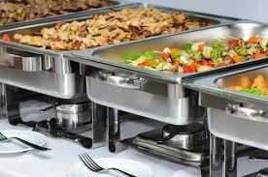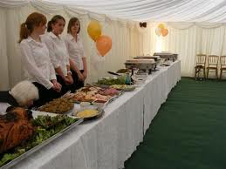

Charlie’s Executive Banqueting Service
A venue, marquee or just at home Charlie’s specialise in two, three, four or even five course banqueting. From starter to dessert we can accomadate a wide range of dishes to suit your budget. Each dish is priced seperatly to enable you to create a menu to suit, why not give us a call and get a quote.
http://www.charliescateringhire.co.uk/catering-services/wedding-catering/wedding-breakfast-2.html

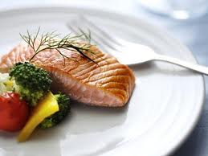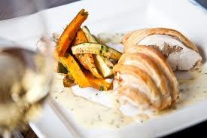

Charlie’s Executive Buffet Service
All types of buffets supplied Budget Buffets – Hot Buffets – Finger Buffets – Cold or Hot Fork Buffets – Funeral Buffets – Children’s Buffets and lots more
http://www.charliescateringhire.co.uk/catering-services.html

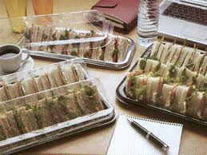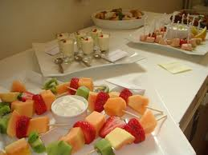

Our Buffets are always supplied and delivered in closed clipped trays with lids to keep quality and freshness. All buffets come with china plates, cutlery, Linen Napkins & Tablecloths. Just order your buffet! And leave the rest to us; we will even set it all up for you. Now that’s Quality and Service.

Charlie’s Executive Canapé Services
You would think that Canapés are just for weddings but you would be mistaken, we cater with a difference and by having canapés we can add that special touch to your event or dinner party. We cater for Canapé Reception – Canapé Party – All Inclusive Canapé Party and Canapé Delivery
http://www.charliescateringhire.co.uk/catering-services.html

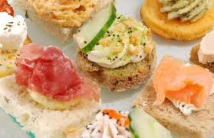

Charlie’s Executive Bowl Food Service
A menu that’s so different it will be talked about long after your event. Ceramic bowls that fit in the palm of your hand with a wide choice of menus that keep your guests returning to try a different dish. This type of menu is really ideal if you want to impress your guests
http://www.charliescateringhire.co.uk/catering-services/bowl-food.html

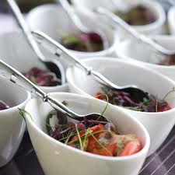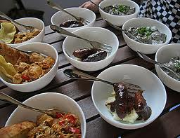

Charlie’s Executive BBQ Service
The summers here so why not try one of our mouth watering BBQs, from easy BBQ which is a budget menu right up to our bespoke menus add the salads include the desserts; it’s an atmosphere waiting to happen.
http://www.charliescateringhire.co.uk/catering-services/buffets/easy-bbq.html
http://www.charliescateringhire.co.uk/catering-services/buffets/bbqs.html

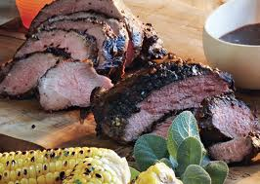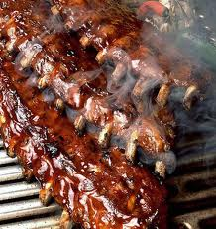

Charlie’s Executive Hand Made Desserts
What better way to finish off your event with some of our handmade desserts all delicately handmade to order for your special day?
http://www.charliescateringhire.co.uk/catering-services/desserts.html

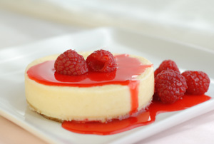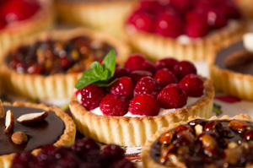

By attaching this type of brochure with the hyperlink we are trying to make viewing of our products as easy as possible when browsing, but should you need us we are always available via the contact details.
Should you require further help or advise please don’t hesitate to contact us where you will have our fullest attention at all times.
If you would like us to come and visit you to discuss more please let us know as this is free of charge service giving you one to one advice.

Why Choose Charlie’s Executive Catering
Our reputation spreads far and wide as we have been in the events business for over 16 years.
We are regularly checked by our local council to meet quality & regulations.
All our employees are qualified to the highest of standards.
We only use Fair Trade Products where possible.
We are insured to the sum of ten million pounds for health and safety.
By using us we can save you cost with our all inclusive packages.
We stock a full equipment hire service to save you using two companies.
We try to accommodate all budgets helping towards your event.
We do hope you like what we have sent you and look forward to speaking with you further to discuss your requirements and being a part of your special day.

Kindest Regards
The Charlie’s Executive Catering Team
www.charliescateringhire.co.uk
info@charliescateringhire.co.uk

